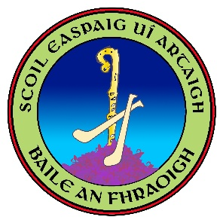

ANNUAL ADMISSION NOTICE Bishop Harty NS
in respect of admissions to the 2024/2025 school year
This Notice will be published at least 1 week before a school can accept applications for admission. It will be published on the school’s website and must remain there for the duration of the school year. It is available on written request through the contact details below.
Admission Policy and Application Form
A copy of the school’s Admission Policy and the Application Form for Admission for the year [2024-25] is available as follows: –
To download at www.ballinreens.ie
On request: By emailing bishophartyns@gmail.com or writing to: [Bishop Harty NS, Ballinree, Nenagh, Co. Tipperary]
Admissions for the 2023-2024 school year
Application and Decision Dates for admission to Bishop Harty NS NS
The following are the dates applicable for admission to Junior Infants
The school will commence accepting applications for admission on  December 30th of the year preceding the start of the school year for which admission is being sought | 18/01/24
The school shall cease accepting applications for admission on | 21/03/2024
The date by which applicants will be notified of the decision on their application is within 3 weeks of the closing date for receipt of application or within 3 weeks of the application date for late applications or within 3 weeks of their application whichever comes first. | 11/04/2024
The period within which applicants must confirm acceptance of an offer of admission is | 09/05/2024
*Failure to accept an offer within the prescribed period above may result in the offer being withdrawn
Note: the school will consider and issue decisions on late applications in accordance with the school’s admission policy.

Number of places being made available in [2024-25]
The number of places being made available in junior infants delete is | 20

